|  |  |
| --- | --- |
| download | COMSATS University Islamabad, Vehari Campus Department of Computer Science |

**Class: BCS-SP22-4B**

**Subject: Data Structures and Algorithms-Lab Instructor: Yasmeen Jana Max Marks: 10Reg. No: SP22-BCS-025**

**Email:** [yasmeenjana@cuivehari.edu.pk](mailto:yasmeenjana@cuivehari.edu.pk)

**You can ask queries related to Lab Activities on the above email.**

# Activity 1: Creating a Github Account

Create a GitHub Account. Make a repository with the name “**DSA_Lab”. Mention the link here after the account creation.**

**SOLUTION:**

**LINK**

//add two numbers using pointer

#include<iostream>

using namespace std;

int main(){

int* p1,*p2;

int num1, num2,sum;

cout<<"add two number \n: ";

cout <<"\n enter teo number of sum: ";

cin>>num1;

cin>>num2;

p1=&num1;

p2=&num2;

sum = *p1 + *p2;

cout<<"sum of two numbers: "<<sum;

return 0;

}

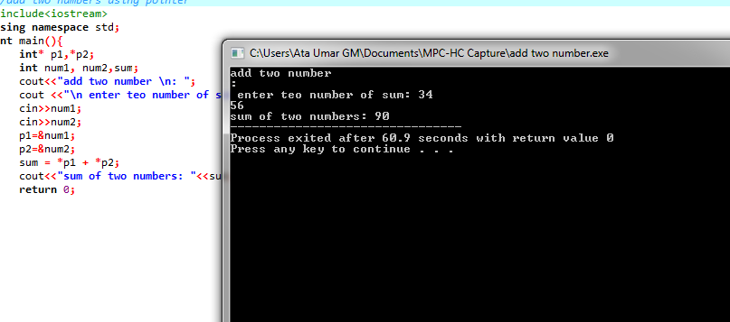

02

/store address and value via pointer

#include<iostream>

using namespace std;

int main(){

int num;

num = 5;

int *p;

p = &num;

// cout << "num = " << num;

cout << "&num = " <<&num<<endl;

cout << "p = " <<p<<endl;

//cout << "*p = " <<*p<<endl;

cout << "&p = " << &p<<endl;

cout << "*&p = "<< *&p<<endl;

return 0;;

}

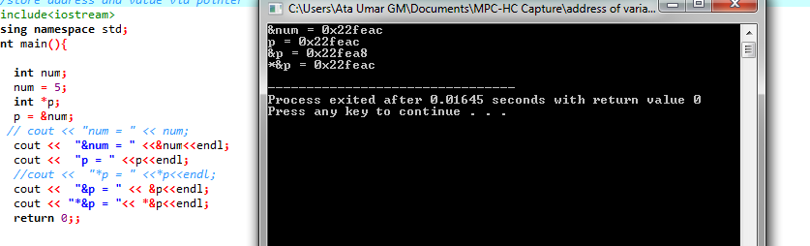

3

count even odd number

#include<iostream>

using namespace std;

int main (){

int num;

int* p;

p = &num;

cout<<" enter a number: ";

cin>>num;

if(num%2==0){

cout<<"even: "<<endl;

}

else {

cout<<"odd: "<<endl;

}

return 0;

}

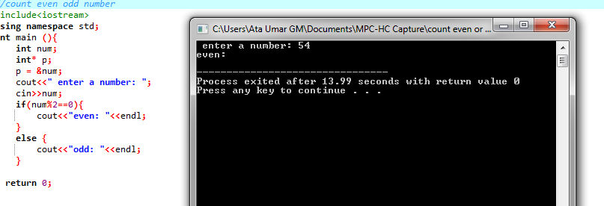

4

factroial number

#include <iostream>

using namespace std;

void findFactorial(int, int *);

int main()

{

int i,fact,num;

cout<<"Enter a number: \n";

cin>>num;

findFactorial(num, &fact);

cout<<"Factorial of " <<num<< " is: "<<fact;

return 0;

}

//function definition

void findFactorial(int num, int *fact){

int i;

*fact=1;

for(i=1; i<=num; i++){

*fact=*fact*i;

}

}

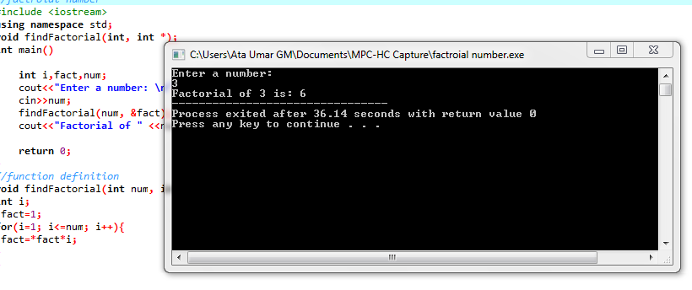

5

/increment and decrement integer pointer

#include<iostream>

using namespace std;

int main(){

int num;

int* p;

num = 10;

p = &num;

cout<<" \n num =: "<<num;

(*p)++;

cout<<" \n num= : "<<num;

++(*p);

cout<<" \n num =: "<<num;

(*p)--;

cout<<" \n num =: "<<num;

--(*p);

cout<<" \n num =: "<<num;

return 0;

}

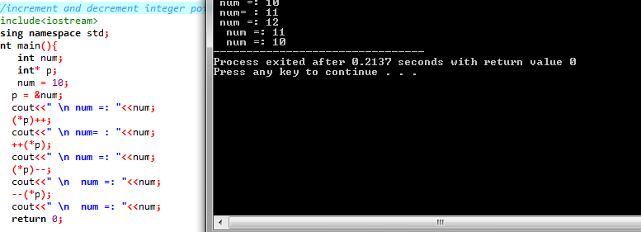

6

length of string via pointer

#include <iostream>

using namespace std;

int main() {

char str[20], *pt;

int i = 0;

cout << "Calculate Length of String \n";

cout << "Enter Any string [below 20 chars] : ";

cin>>str;

pt = str;

while (*pt != '\0') {

i++;

pt++;

}

cout << "\nLength of String : " << i;

return 0;

}

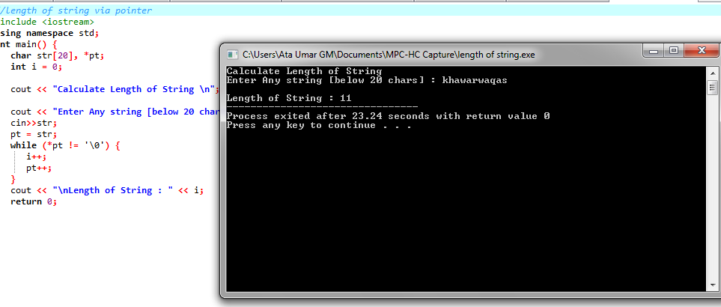7

/difference two number using pointer

#include <iostream>

using namespace std;

int main() {

int *p1, *p2;

int num1, num2, diff;

cout << "a difference between two Numbers \n";

cout << "\nEnter Two Numbers for a Difference : \n";

cin>>num1;

cin>>num2;

p1= &num1;

p2= &num2;

diff = *p1 - *p2;

cout << "Difference :" << diff;

return 0;

}

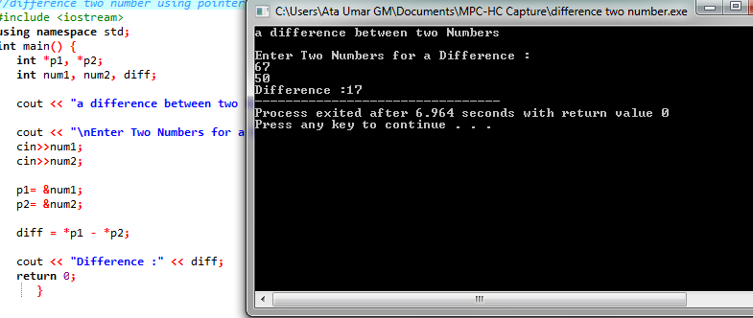

8

//find largest number via pointer

#include<iostream>

using namespace std;

int main()

{ int first,second,*f,*s;

f=&first;

s=&second;

cout<<"Enter first number"<<endl;

cin>>first;

cout<<"Enter second number"<<endl;

cin>>second;

if(*f>*s){

cout<<"Largest="<<*f<<" and smallest="<<*s<<endl;

}else{

cout<<"Largest="<<*s<<" and smallest="<<*f<<endl;

}

return 0;

}

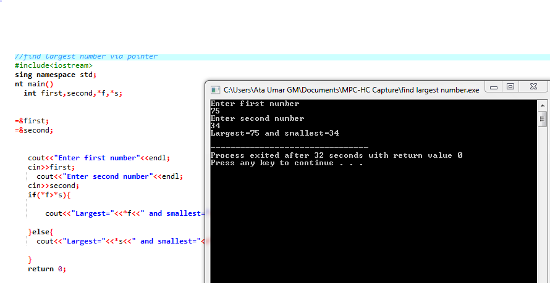

9

//print even number

#include<iostream>

using namespace std;

int main(){

int i;

int* p;

p = &i;

for(*p=2;*p<=10;*p=*p+2){

cout<<*p<<" " ;

}

return 0;

}

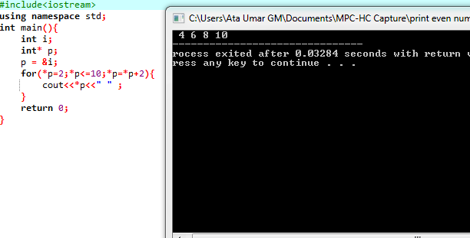

10

/number of table

#include<iostream>

using namespace std;

int main(){

int n;

int *p;

cout<<"enter a number: ";

cin>>n ;

p=&n;

for(int i=1;i<=10;i++){

cout<<n<<" * "<<i<<" = "<<n*i<<endl;

}

return 0;

}

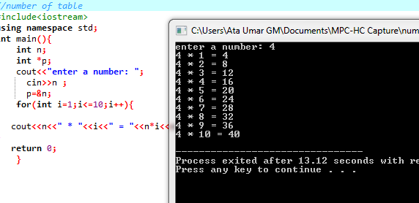

11

/revers order number

#include<iostream>

using namespace std;

int main() {

int n, r, rev = 0;

int *num;

cout << "Enter a number:";

cin >> n;

num = &n;

while (*num > 0) {

r = *num % 10;

rev = rev * 10 + r;

*num = *num / 10;

}

cout << "Reverse number is:" << rev;

return 0;

}

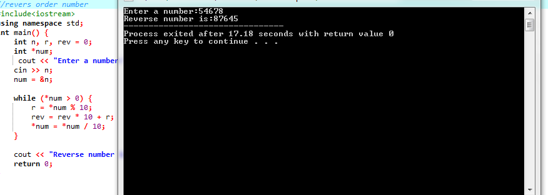

12

/multiplication of number

#include<iostream>

using namespace std;

int main(){

int num1,num2;

int *p1,*p2;

int product;

cout<<" enter the value to numi: "<<endl;

cin>>num1;

cout<<"enter tne value to num2: "<<endl;

cin>>num2;

p1 = &num1;

p2 = &num2;

product = *p1 * *p1;

cout<<"multiplication of the two integer: "<<product;

return 0;

}

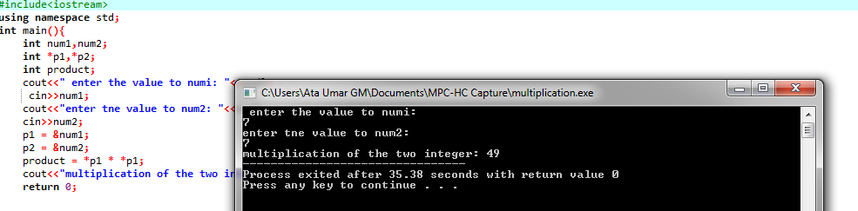

13

//check prime number

#include<iostream>

using namespace std;

int main (){

int n, i,c, count=0;

int* p;

cout<<"enter a number for check for prime: ";

cin>>n;

p =&n;

for(i=1;i<=*p;i++){

if(*p%i ==0)

count++;

}

if(count==2)

cout<<"prime number: ";

else

cout<<"not prime: ";

return 0;

}

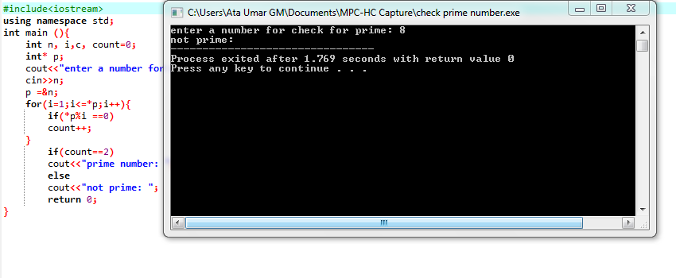

14

/palindrom number

#include<iostream>

using namespace std;

int main(){

int n,num1, r,rev = 0;

int* num;

cout<"<enter anumber: ";

cin>>n;

num1=n;

num = &n;

while(*num>0){

r=*num%10;

rev = rev * 10+r;

*num=*num / 10;

}

if(rev==num1){

cout<<"number is palindrom: "<<num1;

} else {

cout<<"number is not palindrom: "<<num1;

}

return 0;

}

